# HTML – Lesson 7

## COMBINE CSS RULES

* We can combine rules if they are exactly the same:

h1 {

font-family:Georgia;

}

h2 {

font-family:Georgia;

}

Can be combined into:

* If you want finally to specify a specific property for H1, your can do it adding another rule:

h1 {

border-bottom: thick solid black;

}

* You could also have defined H1 and H2 rules **separately**: but in that case, the property font-family would have been written 2 times. Therefore, in case of change, we would have had to update 2 rules. This can become a nightmare if you work with hundred of rules !
* As much as you can, try to **combine** rules shared by different element to **factorize** the code.

## EXTERNALIZE CSS RULES IN A FILE

* There are 3 modes to link CSS rules to HTML code :
  + - **Internal** :
    - **Inline**:
    - **External** :
* To define CSS rules in **external** mode :
  + - Create a CSS file and write your CSS rules
    - Link this CSS file to the HTML code using

<link rel=”stylesheet” href=”../../my-style.css” />

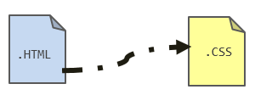

## INHERITANCE

HTML element are organized around a hierarchy:

* All elements (expect HTML) have a parent
* An element can have children : its nested elements

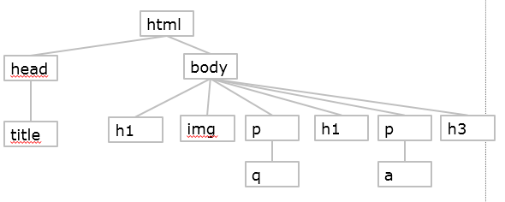

For instance on the above graph: the first P parent is BODY and it contains one child Q

* All elements inherit from the CSS properties of their parents.

For instance on the above graph, if the font for P is defined as Arial, the Q will also have its font defined to Arial: it inherits from the parent properties.

If the BODY element background color is set to BLUE, all element background color will be also BLUE

Let‘s define the following rules :

body { font-family: sans-serif; }

em { font-family: serif; }

} 